**Homework 1 보고서**

**이름: 진방달**

**학번: 2016-23145**

**컴퓨터공학부**

**제출일자: 20170329**

|  |  |
| --- | --- |
| **Y** | Derive glFrustum by your hand |
| **Y** | Derive glOrtho by your hand |
| **Y** | Generate the picking scene |
| **Y** | Get the screen coordinates (provided by the mouse callback function) of the clicked pixel and print the coordinates into standard output |
| **Y** | Unproject the above, i.e., find out the points in the near and far plane that corresponds to the current picking. Print both coordinates into standard output |
| **Y** | Generate the “mouse ray” (cannot be seen ) |
| **Y** | Check intersection between the mouse ray and all the primitives (in this project, spheres) in the viewing volume. If the ray hit something, print the id of the primitive. |
| **Y** | If there is an intersection, the closest one is the object that we want to pick. Apply color change to it.  In my example, I use gray color to sign the picked sphere |
| **Y** | Make the picked object follow the cursor |

**Instructions:**

Click or drag the screen by mouse left button,

* You will see **screen coordinate + near plane picking point, far plane picking point + chosen sphere information** in cmd windows.
* If you clicked the picking sphere, that **sphere color will change to gray.**
* Use mouse left button to **move selected sphere**.

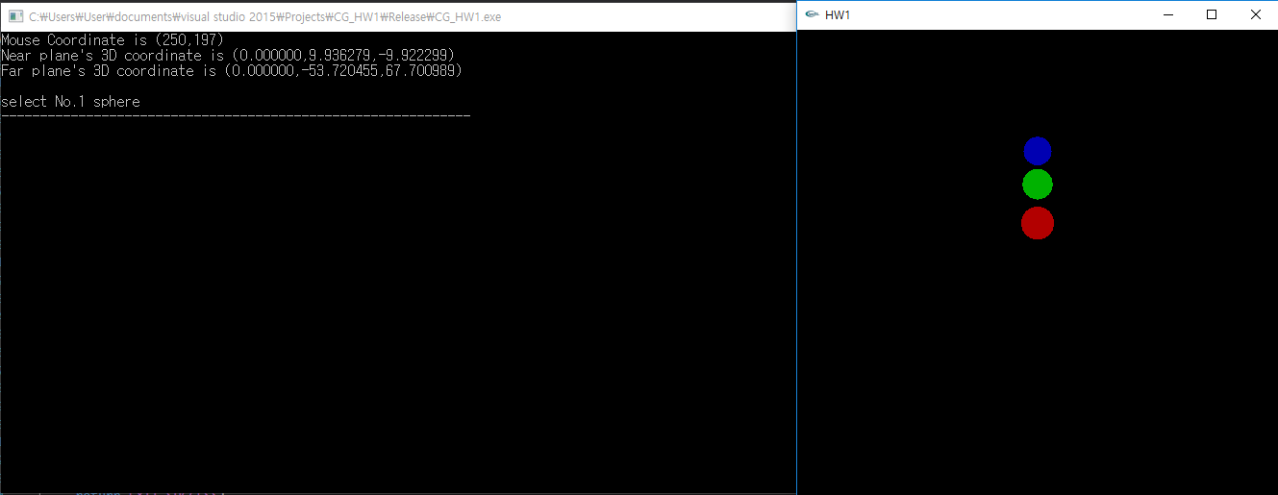

**<figure 1 - click sphere 1>**

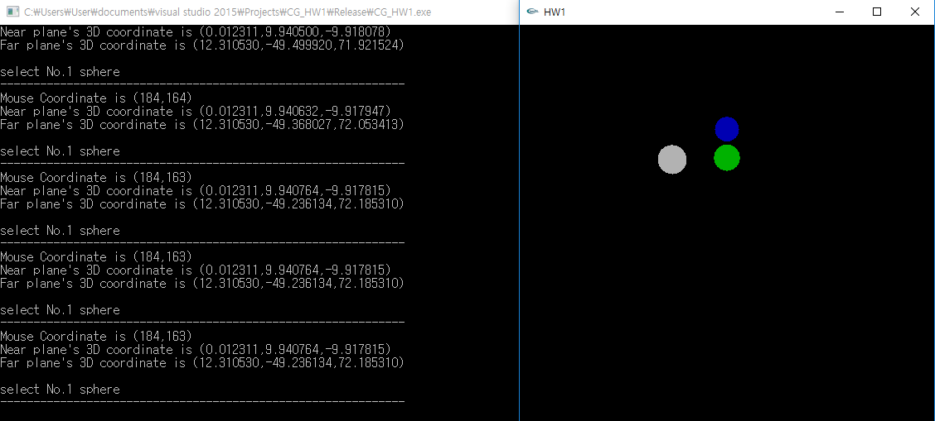

**<figure 2 - drag sphere 1>**

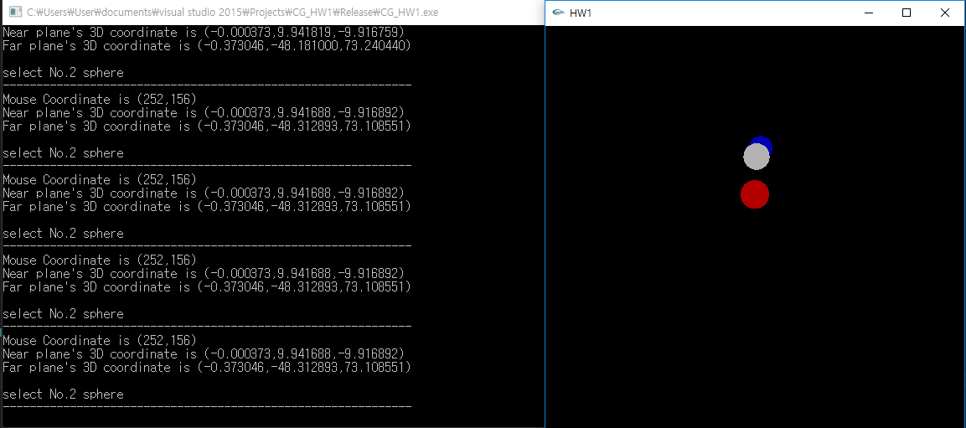

**<figure 3 – pick the nearest sphere when intersection happened>**